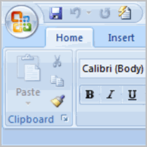**Setting up Your Word Environment**

Before you begin creating documents in Word, you may want to **set up your Word environment** and become familiar with a few **key tasks** such as how to minimize and maximize the Ribbon, configure the Quick Access toolbar, display the ruler, and use the Word Count and Zoom tools.

### Tasks to Set Up and Use Word

##### To Minimize and Maximize the Ribbon:

* Right-click anywhere in the main menu.
* 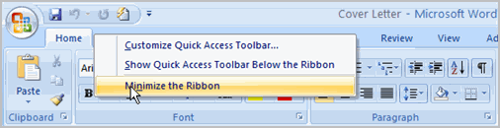Select **Minimize the Ribbon** in the menu that appears. This will **toggle** the Ribbon **on** and **off**.

The **check mark** beside *Minimize the Ribbon* indicates the feature is active.

The new, **tabbed Ribbon system** replaces traditional menus in Word 2007. It is designed to be responsive to your current task and easy to use; however, you can choose to **minimize the Ribbon** if you would prefer to use different menus or keyboard shortcuts.

##### **Quick Access ToolbarTo Add Commands to the Quick Access Toolbar:**

* Click the **arrow** to the right of the Quick Access toolbar.
* Select the **command** you wish to add from the drop-down list. It will appear in the Quick Access toolbar.

The Save, Undo, and Redo commands appear by default in the Quick Access toolbar. You may wish to add other commands to make using specific Word features more convenient for you.

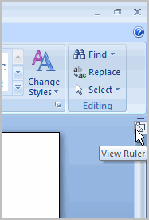**To Display or Hide the Ruler:**

* Click the **View Ruler** icon over the scrollbar.

The **View Ruler** icon works as a toggle button to turn the ruler on and off.

### Word 2007Text Basics

It is important to know how to perform **basic tasks with text** when working in a word processing application. In this lesson you will learn the basics of working with text including how to insert, delete, select, copy, paste, drag and drop text.

### Working with Text

**To Insert Text:**

* Move your mouse to the location you wish text to appear in the document.
* Left-click the mouse. The **insertion point** appears.
* Type the text you wish to appear.

##### To Delete Text:

* Place your cursor next to the text you wish to delete.
* Press the **Backspace** key on your keyboard to delete text to the left of the cursor.
* Press the **Delete** key on your keyboard to delete text to the right of the cursor.

##### To Select Text:

* Place the **insertion point** next to the text you wish to select.
* Left-click your mouse and while holding it down, drag your mouse over the text to select it.
* Release the mouse button. You have selected the text. A **highlighted box** will appear over the selected text.

When you select text or images in Word, a **hover toolbar** with formatting options appears. This makes formatting commands easily accessible, which may save you time.

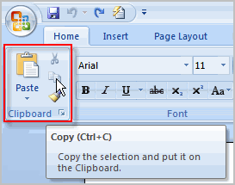

To Copy and Paste Text:

* Select the text you wish to copy.
* Click the **Copy** command on the Home tab.
* Place your insertion point where you wish the text to appear.
* Click the **Paste** command on the Home tab. The text will appear.

##### **Drag and DropTo Drag and Drop Text:**

* Select the text you wish to copy.
* Left-click your mouse and **drag the text** to the location you wish it to appear. The cursor will have a text box under it to indicate that you are moving text.
* Release the mouse button and the text will appear.

If text **does not appear** in the exact location you wish, you can click the **Enter** key on your keyboard to move the text to a new line.

**TRY**

**Use the Cover Letter or any other Word document you choose to complete this challenge.**

* Open an **existing Word document.**
* Select a sentence.
* **Copy and paste** the sentence from one location in the document to another.
* Select another sentence.
* **Drag and drop** it to another location in the document.
* Select the entire document.
* Change the font style, size, and color.

### Word 2007Saving Documents

It is important to know how to save the documents you are working with. There are many ways you **share and receive documents**, which will affect how you need to save the file.   
  
Saving it for the first time? Saving it as another name? Sharing it with someone that does not have Word 2007? All of these things will affect how you **save your Word documents**. In this lesson you will learn how to use the save and save as commands, how to save as Word 97-2003 compatible document, and how to save as a PDF

##### **Save AsTo Use the Save As Command:**

* Click the **Microsoft Office Button**.
* Select **Save As** action**Word Document**. The **Save As** dialog box appears.
* Select the **location** you wish to save the document using the drop-down menu.
* Enter a **name** for the document.

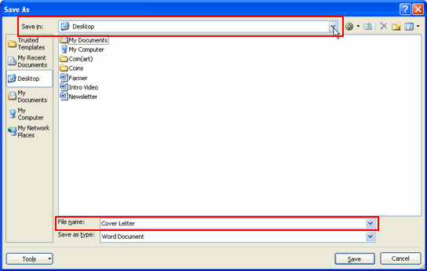

* Click the **Save** button.

##### **Use the Save Command:**

* Click the **Microsoft Office Button**.
* Select **Save** from the menu.

Using the Save command saves the document in its current location using the same file name. If you are saving for the first time and select **Save**, the **Save As** dialog box will appear.

##### To Use the Save As Word 97 - 2003 Document:

* Click the Microsoft Office Button.
* Select Save As actionWord 97-2003 Document.
* 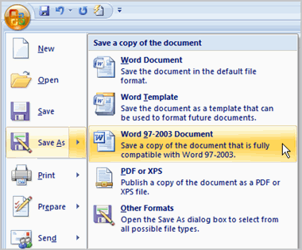Select the location you wish to save the document using the drop-down menu.
* Enter a name for the document.
* Click the Save button.

##### **To Download the PDF Extension:**

* Click the Microsoft Office Button.
* Select Save As actionFind add-ins for other file formats. This will open your web browser to the Microsoft site.
* Follow the instructions on the Microsoft site for downloading the extension.

##### Save As PDFTo Save As a PDF:

* Click the Microsoft Office Button.
* Select Save As actionPDF. The Save As dialog box will appear.
* Select the location you wish to save the document using the drop-down menu.
* Enter a name for the document.
* Click the Publish button.

**Challenge**

**Use the Cover Letter or any other Word document you choose to complete this challenge.**

* Open an existing Word document.
* Save the document with the file name **trial**.
* Save the **same document** as a PDF file.
* Close the document.
* Open **another** existing Word document.
* Save the document so that it is **compatible** with Word 2003.
* Close the document.

### Proofing Features

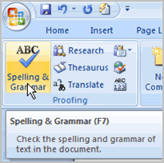Worried about making mistakes when you type? Don't be. Word provides you with several **proofing features** that will help you produce professional, error-free documents. In this lesson you will learn about the various proofing features, including the Spelling and Grammar tool.

**Various Line Colors:**

By default, Word automatically checks your document for **spelling and grammar** errors. These errors are indicated by **colored wavy lines**.

* The **blue line** indicates a contextual spelling error.

A **contextual spelling** error is when an incorrect spelling of a word is chosen. For example, if I write, "Deer Mr. Theodore," at the beginning of a letter, **deer** is a contextual spelling error because I should have used **dear**. **Deer** is spelled correctly, but it is used incorrectly in this letter.

* 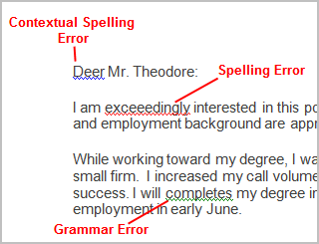The **red line** indicates a misspelled word.
* The **green line** indicates a grammar error.

##### **To Use the Spelling Check Feature:**

* Right-click the **underlined** word. A menu will appear.
* Select the **correct spelling** of the word from the **listed suggestions**.
* Left-click your mouse on the word. It will appear in the document.

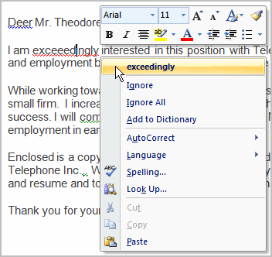You can choose to **Ignore** an underlined word, add it to the **dictionary**, or go to **Spelling** dialog box.

##### **Grammar CheckTo Use the Grammar Check Feature:**

* Right-click the **underlined** word. A menu will appear.
* Select the **correct word** from the **listed suggestions**.
* Left-click your mouse on the word. It will appear in the document.

You can also choose to **Ignore** an underlined word, go to **Grammar** dialog box, or find out **more information** about the word and its usage.

You can also wait and run the spelling and grammar check **after completing the document**. Click the **Spelling & Grammar command** on the Review tab.

**Challenge!**

**Use the Cover Letter or any other Word document you choose to complete this challenge.**

* Open an **existing** Word document.
* Type the following sentences at the beginning of the document:
  + I really enjoy learning an computers and about new skillz.
  + I like to take tutorials were I can learn independently.
* Correct the **spelling errors** in the sentences.
* Correct the **grammar mistake** that appears in one of the sentences.
* Use the **Spelling and Grammar command** to check the remainder of the document.

### Working with Hyperlinks

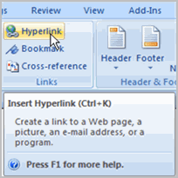A **hyperlink** is a piece of **text** or an **image** in an electronic document that can connect readers to another portion of the document or a different web page. In addition, a hyperlink can be used to connect to and open an email client window.   
Ever noticed the **active links** on web pages that allow you to **jump from one page to another?** You just used one to open this lesson. These are **hyperlinks**. You can use these in electronic versions of your Word documents just like you do in web pages. In this lesson you will learn the **basics of working** with hyperlinks, including how to insert and remove them in your Word document.

### Hyperlinks

##### **To Insert a Hyperlink:**

* Select the **text or image** you would like to make a **hyperlink**.
* Select the **Insert** tab.
* Click **Hyperlink** in the Links group. The Insert Hyperlink dialog box appears. If you selected text, the words will appear in the **Text to display:** field at the top.
* 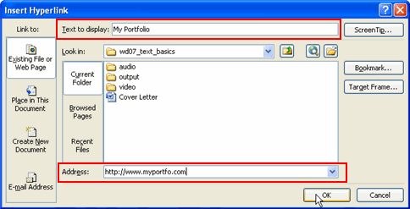Type the address you would like to link to in the **Address:** field.
* Click **OK**. The text or image you selected will now be a hyperlink.

You can also insert a hyperlink that links to **another portion of the same document**.

Word recognizes many emails and web addresses as you type and will format them as hyperlinks automatically after you press the **Enter** key or **spacebar**.

##### **Select Remove HyperlinkTo Remove a Hyperlink:**

* Select the **hyperlink** you would like to deactivate.
* Select the **Insert** tab.
* Click **Hyperlink** in the Links group. The Edit Hyperlink dialog box appears.

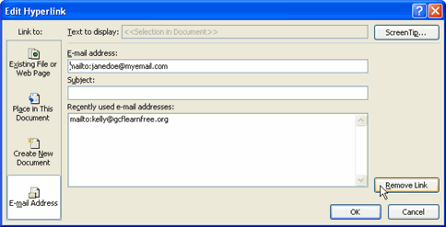

* Click **Remove Link**.

**Challenge**

**Use the Cover Letter or any other Word document you choose to complete this challenge.**

* Open an **existing** Word document.
* Type the following sentence:
* Select **CSUC**.
* Insert a hyperlink that connects to **www.csus.edu.gh**.
* Remove the hyperlink.

### Printing Documents

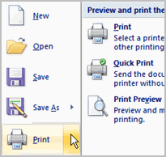Once you complete your document, you may want to **print** it for various reasons. This lesson covers the three basic features of printing in Word including **Print Preview**, **Quick Print**, and **traditional Print**.

### Print PreviewPrinting

##### **To Preview the Document Before Printing:**

* Click the Microsoft Office Button.
* Select **Print** action**Print Preview**. The document opens in Print Preview format.

Click **Print** to print the document or **Close Print Preview** to exit the preview format and make changes to the document.

In **Print Preview format**, you can do many tasks including:

* Modify the margins
* Change page orientation
* Change the page size
* Zoom in and out to view various parts of the document
* View multiple pages
* Access Word Options to change many Word settings
* And more

##### To Print:

* Click the Microsoft Office Button.
* Select **Print**action**Print**. The Print dialog box appears.
* Select the pages you would like to print -- either **all pages** or a **range** of pages.
* Select the **number of copies**.
* Check the **Collate** box if you are printing multiple copies of a multi-page document.
* 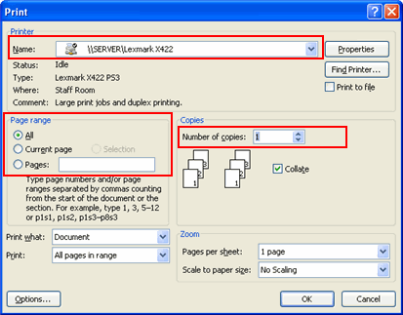Select a printer from the drop-down list.
* Click OK.

##### **To Print via Quick Print:**

* Click the Microsoft Office Button.
* Select **Print**action**Quick Print**.
* The document automatically prints to the default printer.

**Challenge!**

**Use the Cover Letter or any other Word document you choose to complete this challenge.**

* Open an existing document.
* View the document in **Print Preview.**
* Close the Print Preview format **without** printing.
* Print two copies of the document.

### Creating a New Document

In addition to working with existing documents, you will want to be able to **create new documents**. Each time you open Word, a new, blank document appears; however, you will also need to know how to create new documents while an existing document is open.   
  
In this lesson you will learn how to create new documents including templates and **blank documents** via the Microsoft Office Button.

### New Document

### New Documents

##### **To Create a New, Blank Document:**

* Click the **Microsoft Office Button**.
* Select **New**. The New Document dialog box appears.
* Select **Blank document** under the **Blank and recent** section. It will be highlighted by default.
* Click **Create**. A new, blank document appears in the Word window.

You can access templates that are installed on your computer or on Office Online. Click the Microsoft Office Button and select **New.** You can create blank documents and access templates from the dialog box that appears.

**Challenge!**

* Open Word. A **blank document** appears in the window.
* Type the sentence, "GCFLearnFree.org is a great, free resource."
* Click the **Microsoft Office Button** and create a new, blank document.
* Close both Word documents **without saving**.

### Formatting Text

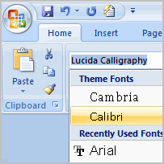To create and design effective documents, you need to know how to **format text**. In addition to making your document more appealing, **formatted text** can draw the reader's attention to specific parts of the document and help communicate your message.   
  
In this lesson you will learn to format the font size, style, and color; and use the Bold, Italic, Underline, and Change Case commands.

### Font SizeFormat Text

##### To Format Font Size:

* Select the text you wish to modify.
* Left-click the **drop-down arrow** next to the **font size box** on the Home tab. The font size drop-down menu appears.
* Move your cursor over the various font sizes. A **live preview** of the font size will appear in the document.
* Left-click the font size you wish to use. The font size will change in the document.

##### Font StyleTo Format Font Style:

* Select the text you wish to modify.
* Left-click the **drop-down arrow** next to the **font style box** on the Home tab. The font style drop-down menu appears.
* Move your cursor over the various font styles. A **live preview** of the font will appear in the document.
* Left-click the font style you wish to use. The font style will change in the document.

##### Font ColorTo Format Font Color:

* Select the text you wish to modify.
* Left-click the drop-down arrow next to the **font color box** on the Home tab. The font color menu appears.
* Move your cursor over the various font colors. A live preview of the color will appear in the document.
* Left-click the font color you wish to use. The font color will change in the document.

Your color choices aren't limited to the drop-down menu that appears. Select **More Colors** at the bottom of the list to access the Colors dialog box. Choose the color that you want and click OK.

##### **Formatting CommandsUse the Bold, Italic, and Underline Commands:**

* Select the text you wish to modify.
* Click the Bold, Italic, or Underline command in the **Font group** on the Home tab.

##### Change CaseTo Change the Text Case:

* Select the text you wish to modify.
* Click the **Change Case** command in the **Font** group on the Home tab.
* Select one of the case options from the list.

##### **To Change Text Alignment:**

* 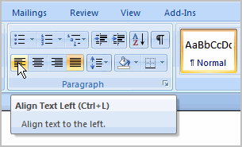Select the text you wish to modify.
* Select one of the four **alignment options** from the Paragraph group on the Home tab.
  + **Align Text Left:** Aligns all the selected text to the left margin.
  + **Center:** Aligns text an equal distance from the left and right margins.
  + **Align Text Right:** Aligns all the selected text to the right margin.
  + **Justify:** Justified text is equal on both sides and lines up equally to the right and left margins. Traditionally many books, newsletters, and newspapers use full-justification.

**Challenge!**

* Create a new, blank Word document.
* Insert text into the document.
* Change the **font size** of some text.
* Change the **font style** of some text.
* Change the **font color** of some text.
* Try various cases using the Change Case command.
* Try the 4 alignment commands.
* Save the document if you wish.

### Working with Text boxes

You may want to **insert a text box** into your document to draw attention to specific text or so that you have the ability to **easily move text** around within a document.   
  
In this lesson you will learn how to insert a text box and how to format it in various ways including resizing and moving it, and changing the text box shape, color, and outline.

### Text Boxes

##### **To Insert a Text box:**

* 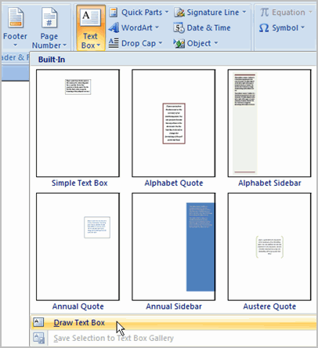Select the **Insert** tab on the Ribbon.
* Click the **Text Box** command in the **Text** group.
* Select a **Built-in text box** or **Draw Text Box** from the menu.
* If you select **Built-in text box**, left-click the text box you wish to use and it will appear in the document.

**OR**

* If you select **Draw Text Box**, a crosshair cursor will appear. Left-click your mouse and while holding it down, drag your mouse until the text box is the desired size.
* Release the mouse button.

##### **Format TabTo Change Text Box Style:**

* Select the text box. A new **Format tab** appears with Text Box Tools.
* Select the Format tab.
* Click the **More drop-down arrow** in the Text Box Style group to display more style options.

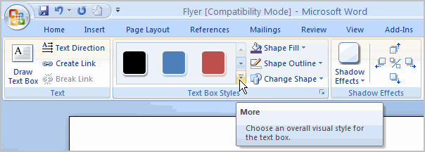

* 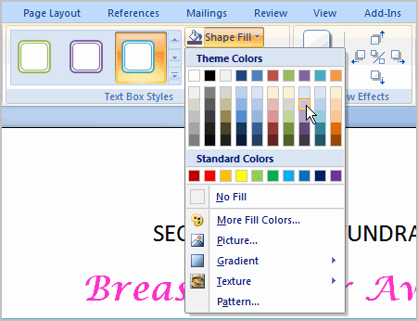Move your cursor over the styles and Live Preview will preview the style in your document.
* Left-click a style to select it.

##### **To Change Shape Fill:**

* Select the text box. A new **Format tab** appears with Text Box Tools.
* Click the **Shape Fill** command to display a drop-down list.
* Select a color from the list, choose No Fill, or choose one of the other options.

##### Shape Outline

##### To Change the Shape Outline:

* Select the text box. A new **Format tab** appears with Text Box Tools.
* Click the **Shape Outline** command to display a drop-down list.
* Select a color from the list, choose No Outline, or choose one of the other options.

##### **To Change the Text Box Shape:**

* 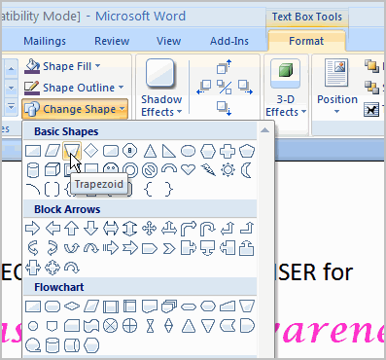Select the text box. A new **Format tab** appears with Text Box Tools.
* Click the **Change Shape** command to display a drop-down list.
* Select a shape from the list.

##### **To Move a Text Box:**

* Left-click the text box. Your cursor becomes a **cross with arrows** on each end.
* While holding the mouse button, **drag** the text box to the desired location on the page.
* Release the mouse button.

##### **To Resize a Text Box:**

* Select the text box.
* Left-click one of the **blue sizing handles**.
* While holding down the mouse button, **drag the sizing handle** until the text box is the desired size.

If you drag the **blue sizing handles** on any of the 4 corners, the text box will resize in the **same proportions**. The sizing handles on the top or bottom of the text box will allow you to resize **vertically**, while the handles on the left and right sides will resize the text box **horizontally**.

**Challenge!**

**Use the Flyer or any other Word document you choose to complete this challenge.**

* Open an existing document.
* Insert a text box.
* Change the **outline** of the text box to a different color.
* Change the **fill color** of the text box.
* **Move** the text box to the desired location.
* Enter any text you wish into the text box.

### Inserting Clip Art

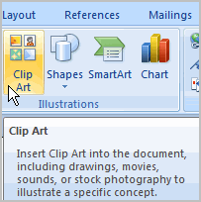You may want to insert various types of **illustrations** into your documents to make them more visually appealing. Illustrations include ClipArt, Pictures, SmartArt, Charts, and more.   
  
In this lesson you will learn how to search for and locate clip art, and insert it into your documents.

### Working with ClipArt

##### **Insert ClipArtTo Locate Clip Art:**

* Select the **Insert** tab.
* 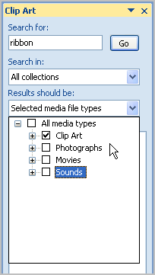Click the **Clip Art** command in the **Illustrations** group.
* The Clip Art options appear in the **task pane** on the right.
* Enter keywords in the **Search for:** field that is related to the image you wish to insert.
* Click the drop-down arrow next to the **Search in:** field.
* Select **Everywhere** to ensure that Word searches your computer and it's online resources for an image that meets your criteria.
* Click the drop-down arrow in the **Results should be:** field.
* Deselect any types of images you do not wish to see.
* Click **Go**.

##### **InsertTo Insert Clip Art:**

* Review the results from a clip art search.
* Place your **insertion point** in the document where you wish to insert the clip art.
* Left-click an image in the task pane. It will appear in the document.

OR

* Left-click the **arrow next to an image** in the task pane.
* Select Insert, Copy, or any of the other options on the list.

**Challenge!**

**Use the Flyer or any other Word document you choose to complete this challenge.**

* Open an existing Word document.
* Insert a clip art image from Office Online.

### Working with Shapes

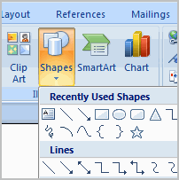You can add a **variety of shapes** to your document including arrows, callouts, squares, stars, flowchart symbols and more. Want to off-set your name and address from the rest of your resume? Use a line. Need to show the progress of a document through your office? Use a flow chart. While you may not need shapes in every document you create, they can add **visual appeal and clarity** to many documents.   
  
In this lesson you will learn how to insert a shape and format it by changing its fill color, outline color, shape style, and shadow effects. Additionally, you will learn to apply 3-D effects to shapes that have this option.

### Using Shapes

##### To Insert a Shape:

* Select the **Insert** tab.
* Click the **Shape** command.
* Left-click a shape from the menu. Your cursor is now a cross shape.
* Left-click your mouse and while holding it down, drag your mouse until the shape is the desired size.
* Release the mouse button.

##### **To Change Shape Style:**

* Select the shape. A new **Format tab** appears with Drawing Tools.

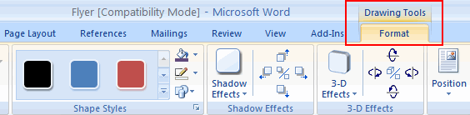

* Click the **More drop-down arrow** in the Shapes Style group to display more style options.

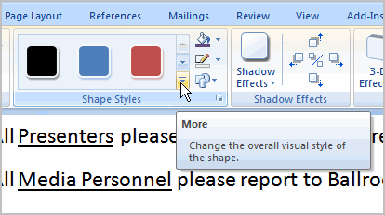

* Move your cursor over the styles and Live Preview will preview the style in your document.
* Left-click a style to select it.

##### **To Change the Shape Fill Color:**

* 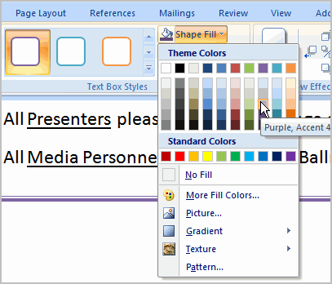Select the shape A new **Format tab** appears with Drawing Tools.
* Click the **Shape Fill** command to display a drop-down list.
* Select a color from the list, choose No Fill, or choose one of the other options.

##### **To Change the Shape Outline:**

* Select the shape. A new **Format tab** appears with Drawing Tools.
* Click the **Shape Outline** command to display a drop-down list.
* Select a color from the list, choose No Outline, or choose one of the other options.

##### **Change ShapeChange to a Different Shape:**

* Select the shape. A new **Format tab** appears with Drawing Tools.
* Click the **Change Shape** command to display a drop-down list.
* Select a shape from the list.

##### **To Change Shadow Effects:**

* Select the **Format** tab.
* Left-click the **Shadow Effects** command.
* Move your mouse over the menu options. Live Preview displays how it will appear in your document.
* Click an option to select the shadow effect.

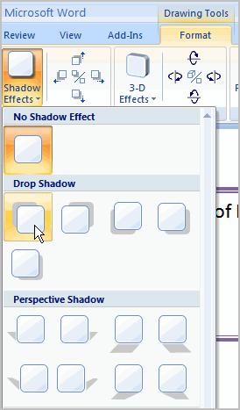

Select **Shadow Color** from the menu and choose a color from the palette to change the color of the shadow on your shape.

##### **To Change 3D Effects:**

* Select the **Format** tab.
* Left-click the **3-D Effects** command.
* Move your mouse over the menu options. Live Preview displays how it will appear in your document.
* Click an option to select the 3-D effect.

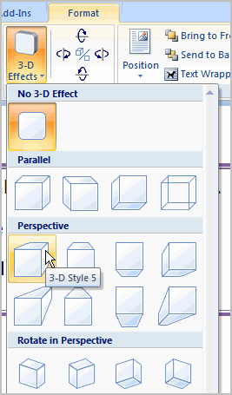You can not add a 3D effect to **all shapes**.

After you have chosen a **3D effect**, you can also change some other elements of your shape including the **color, depth, direction, lighting, and surface** of the 3D effect on your shape. This can change the way the shape looks dramatically. You can access these options by clicking the 3D Effects command.

**Challenge!**

**Use the Flyer or any other Word document you choose to complete this challenge.**

* Open an existing Word document.
* Insert a **shape**.
* Change the shape to a **different shape**.
* Change the **fill color**.
* Change the line color.
* Try various shadow effects.
* Try various 3D effects.

### Using a Template

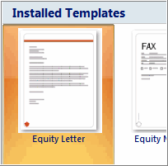A **template** is a pre-designed document that you can use to create new documents with the **same formatting**. With a template, many of the big document design decisions such as margin size, font style and size, and spacing are predetermined.   
  
You will learn how to create a new document with a template and insert text, as well as basic information about how templates work in Word 2007.

### Installed Templates

### Create a New Document with a Template

##### **To Insert a Template:**

* Click the **Microsoft Office Button**.
* Select **New**. The New Document dialog box appears.
* Select **Installed Templates** to choose a template on your computer.
* Review the available templates.
* Left-click a template to select it.
* Click **Create** and the template opens in a new window.

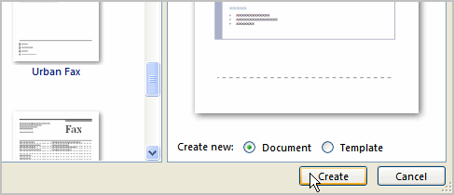

You can select any of the categories in the **Microsoft Office Online** section of the New Document Dialog box. This will display templates that are available online free of charge. Your computer must have Internet access to download these templates.

##### **Information about Using Templates**

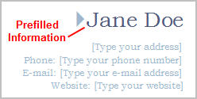Templates include **placeholder text** that is surrounded by **brackets**. Often, this placeholder text includes information regarding the content for a specific area.   
  
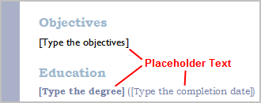  
  
Additionally, some information is **prefilled** in the template. You can modify your Word Options and change the prefilled information that appears.   
  
  
  
  
Word templates may include separate **Quick Parts** sections that give you various options for the template.

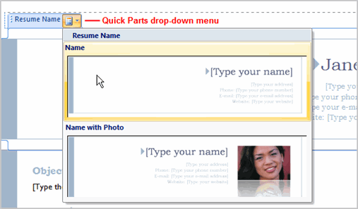

##### **To Insert Text into a Template:**

* Click **near** the text you want to replace. The text will appear **highlighted** and a template **tag** will appear.

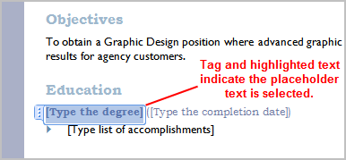

* Enter text. The placeholder text will disappear.

##### To Change Prefilled Information:

* Select the **Microsoft Office Button**.
* Click the **Word Options** button at the bottom of the menu. The Word Options dialog box appears.
* Enter the **user name and/or initials** in the Popular section.

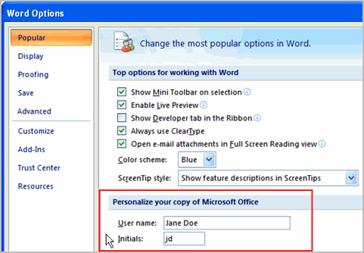

* Click OK.

**Challenge!**

* Create a **new document** using a **template**.   
  **Note:** Choose the Origins Resume template to follow along with the video.
* Enter text into the template.
* Modify the **user name** and **initials** for your version of Word if you are using a home computer.   
  **Note:** If you are using a public computer such as one at a library, you do not need to change these settings.
* Save the document.

### Working with Lists

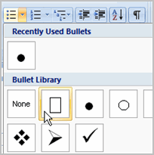Bulleted and numbered lists can be used in your documents to **arrange and format text** to draw emphasis. In this lesson, you will learn how to modify existing bullets, insert new bulleted and numbered lists, and select symbols as bullets.

### Bulleted and Numbered Lists

[Watch the video!](http://www.gcflearnfree.org/content/screencasts/shared/player_776x600.aspx?screenCast=wd07_lists) (4:13 min) - [Tips](http://www.gcflearnfree.org/PopUps/VideoTips.aspx) for watching our videos.

Download the [example](http://www.gcflearnfree.org/content/downloads/wd07_Resume_lesson13.docx) to work along with the video.

##### To Insert a New List:

* Select the text that you want to format as a list.
* Click the **Bullets** or **Numbering** commands on the Home tab.

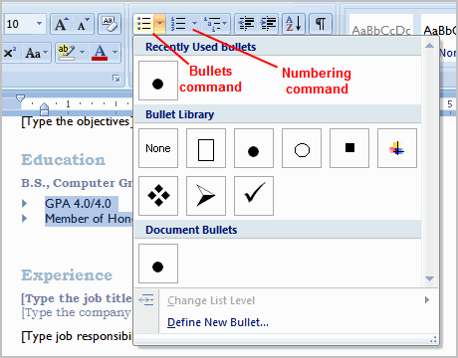

* Left-click the bullet or numbering style you would like to use. It will appear in the document.
* Position your cursor at the end of a list item and press the **Enter** key to add an item to the list.

To remove numbers or bullets from a list, select the list and click the **Bullets** or **Numbering** commands.

##### To Select an Alternate Bullet or Numbering Style:

* Select all of the text in an existing list.
* Click the **Bullets** or **Numbering** commands on the Home tab.
* Left-click to select an alternate bullet or numbering style.

### Bulleted Lists

##### To Use a Symbol as a Bullet:

* Select an existing list.
* Click the **Bullets** command.
* Select **Define New Bullet** from the list. The Define New Bullet dialog box appears.
* Click the **Symbol** button. The Symbol dialog box appears.

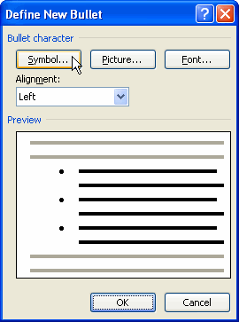

* Click the **Font:** drop-down box and select a font category.

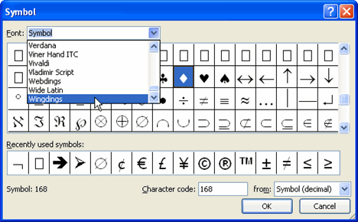

* Left-click a symbol to select it.
* Click OK. The symbol will now appear in the Preview section of the Define New Bullet dialog box.
* Click OK to apply the symbol to the list in the document.

You can use a picture as a bullet. Click the **Picture** button in the Define New Bullet dialog box, and then locate the image file on your computer.

##### To Change the Bullet Color:

* Select an existing list.
* Click the **Bullets** command.
* Select **Define New Bullet** from the list. The Define New Bullet dialog box appears.
* Click the **Font** button. The Font dialog box appears.

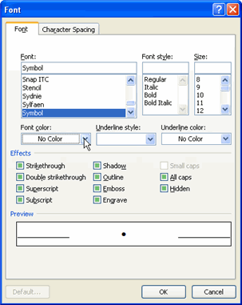

* Click the **Font color:** drop-down box.
* Left-click a color to select it.
* Click OK. The bullet color will now appear in the Preview section of the Define New Bullet dialog box.
* Click OK to apply the bullet color to the list in the document.

You can also change the bullet font and formatting in the Font dialog box.

**Challenge!**

**Use the Resume or any Word template you choose to complete this challenge.**

* Change the bullet of an existing list to a different bullet.
* Insert a **new numbered list** into the document.
* Modify the **color** of a bullet.

### Line and Paragraph Spacing

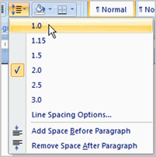An important part of creating effective documents lies in the document design. As part of designing the document and making formatting decisions, you will need to know how to **modify the spacing**. In this lesson, you will learn how to modify the line and paragraph spacing in various ways.

### Modifying Spacing

[Watch the video!](http://www.gcflearnfree.org/content/screencasts/shared/player_776x600.aspx?screenCast=wd07_line_para_spacing) (3:34 min) - [Tips](http://www.gcflearnfree.org/PopUps/VideoTips.aspx) for watching our videos.

Download the [example](http://www.gcflearnfree.org/content/downloads/wd07_Resume_lesson14.docx) to work along with the video.

##### To Format Line Spacing:

* **Select** the text you want to format.
* Click the **Line spacing** command in the Paragraph group on the Home tab.
* Select a spacing option.



OR

* Select **Line Spacing Options**. The Paragraph dialog box appears.

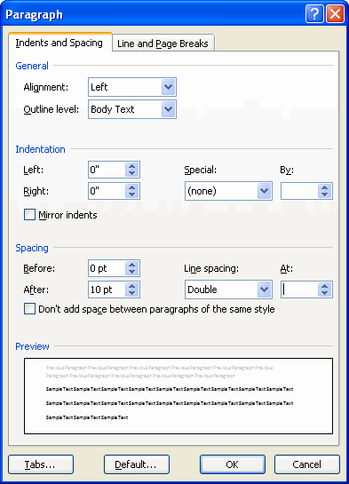

* Use the **Line spacing** drop-down menu to select a spacing option.
* Modify the **before and after** points to adjust line spacing, as needed.
* Click **OK**.

Just as you can format spacing between lines in your document, you can also choose spacing options between each paragraph. Typically, extra spaces are added between paragraphs, headings, or subheadings. Extra spacing between paragraphs adds emphasis and makes a document easier to read.

##### To Format Paragraph Spacing

* Click the **Line spacing** command on the Home tab.
* Select **Add Space Before Paragraph** or **Remove Space After Paragraph** from the menu.

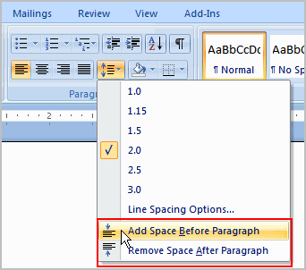

OR

* Select **Line Spacing Options**. The Paragraph dialog box appears.
* Change the **Before** and **After** points in the Paragraph section.

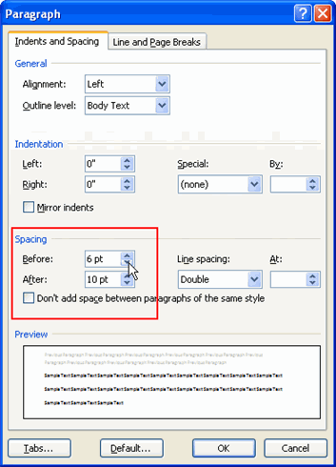

* Click **OK**.

Line spacing is measured in **lines or points**, which is referred to as **leading**. When you reduce the leading, you automatically bring the lines of text closer together. Increasing the leading will space the lines out, allowing for improved readability.

**Challenge!**

**Use the Resume or any Word template you choose to complete this challenge.**

* Change the **line spacing** of a list.
* Change the line spacing of a paragraph of text.
* Change the **paragraph spacing** between body text and a heading.

### Modifying Page Layout

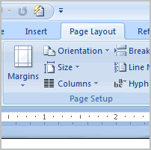You may find that the **default page layout settings** in Word are not sufficient for the document you wish to create, in which case you will want to modify those settings. In addition, you may want to change the **page formatting** depending on the document you are creating.  
  
In this lesson, you will learn how to change the page orientation, paper size, and page margins, and insert a break.

### Page Layout and Formatting

[Watch the video!](http://www.gcflearnfree.org/content/screencasts/shared/player_776x600.aspx?screenCast=wd07_page_layout) (5:54 min) - [Tips](http://www.gcflearnfree.org/PopUps/VideoTips.aspx) for watching our videos.

Download the [example](http://www.gcflearnfree.org/content/downloads/wd07_Newsletter_lesson15.docx) to work along with the video.

##### To Change Page Orientation:

* Select the **Page Layout** tab.
* Click the **Orientation** command in the Page Setup group.

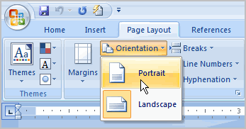

* Left-click either **Portrait** or **Landscape** to change the page orientation.

**Landscape** format means that everything on the page is oriented **horizontally** and **portrait** format is oriented **vertically**.

.

##### To Change the Paper Size:

* Select the Page Layout tab.
* Left-click the **Size** command and a drop-down menu will appear. The current paper size is highlighted.

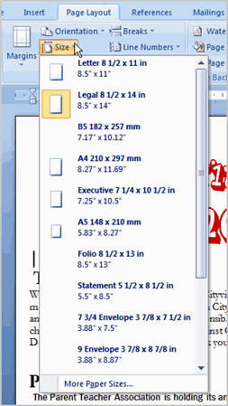

* Left-click a **size option** to select it. The page size of the document changes.

##### To Format Page Margins:

* Select the **Page Layout** tab.
* Click the **Margins** command. A menu of options appears. **Normal** is selected by default.
* Left-click the predefined margin size you want.

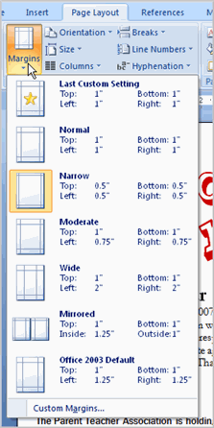

OR

* Select **Custom Margins** from the menu. The Page Setup dialog box appears.

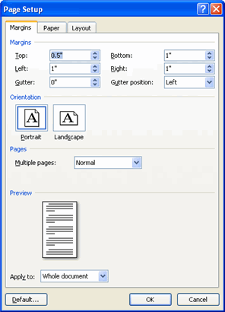

* Enter the desired margin size in the appropriate fields.

You can always access the **Page Setup** dialog box by clicking the small arrow in the bottom-right corner of the Page Setup group. The dialog box should look familiar to people who have used previous versions of Word.

##### To Insert a Break:

* Place your **insertion point** where you want the **break** to appear.
* Select the **Page Layout** tab.
* Click the **Breaks** command. A menu appears.

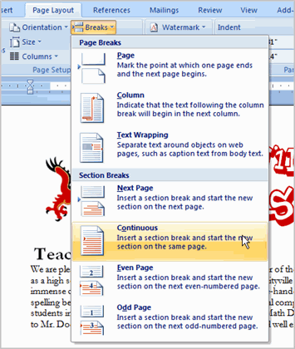

* Left-click a **break option** to select it. The break will appear in the document.

Why would you need to use a break? Each **type of break** serves a different purpose and will affect the document in different ways. **Page breaks** move text to a new page before reaching the end of a page, while **section breaks** create a barrier between parts of the document for formatting purposes. **Column breaks** split text in columns at a specific point. Practice using the various break styles to see how they affect the document.

**Challenge!**

**Use the Newsletter or any Word document you choose to complete this challenge.**

* Change the **page orientation**.
* Change the paper size.
* Modify **at least** one margin.
* Insert a section break.

### Working with Pictures

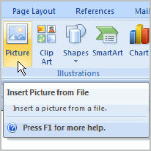Pictures can be added to Word documents and then formatted in various ways. The **picture tools** in Word 2007 make it easy to incorporate images into your documents and **modify those images** in innovative ways.   
  
In this lesson, you will learn how to insert a picture from your computer, change the picture style and shape, add a border, crop and compress pictures, and more.

### Inserting and Modifying Pictures

[Watch the video!](http://www.gcflearnfree.org/content/screencasts/shared/player_776x600.aspx?screenCast=wd07_image_basics) (7:33 min) - [Tips](http://www.gcflearnfree.org/PopUps/VideoTips.aspx) for watching our videos.

Download the [example](http://www.gcflearnfree.org/content/downloads/wd07_Newsletter_lesson16.docx) to work along with the video.

##### To Insert a Picture:

* Place your **insertion point** where you want the image to appear.
* Select the **Insert** tab.
* Click the **Picture** command in the **Illustrations** group. The Insert Picture dialog box appears.

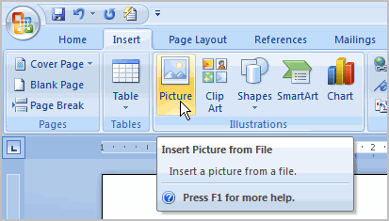

* Select the image file on your computer.

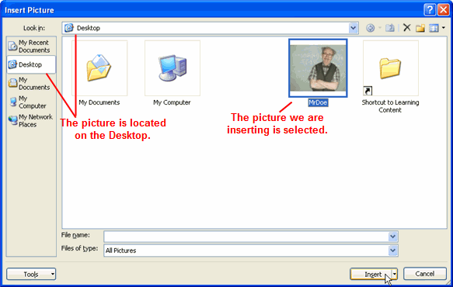

* Click **Insert** and it will appear in your document.

Left-click a **corner sizing handle**, and while holding down the mouse button, resize the image. The image retains its proportions.

##### To Wrap Text Around an Image:

* Select the image.
* Select the **Picture Tools Format** tab.
* Click the **Text Wrapping** command in the Arrange group.

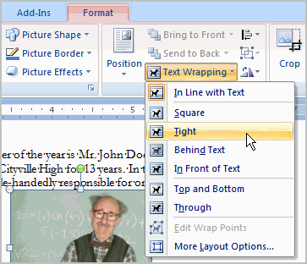

* Left-click a menu option to select it. In this example, we selected **Tight**.
* Move the image around to see how the text wraps for each setting.

If you can’t get your text to wrap the way you wish, click the **Text Wrapping** command and select **More Layout Options** from the menu. You can make more precise changes in the Advanced Layout dialog box that appears.

##### To Crop an Image:

* Select the image.
* Select the **Format** tab.
* Click the **Crop** command. The black cropping handles appear.

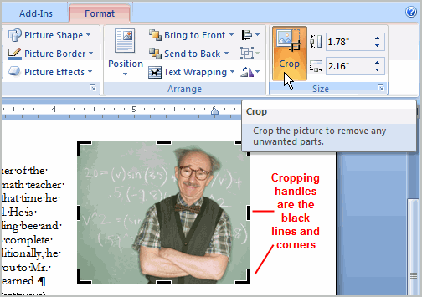

* Left-click and move a **handle** to crop an image.
* Click the **Crop** command to deselect the crop tool.

Corner handles will crop the image proportionally.

##### To Compress a Picture:

* Select the picture.
* Select the **Format** tab.
* Click the **Compress Pictures** command in the Adjust group. A dialog box appears.
* Click the **Options** button to access the **Compression Setting** dialog box.

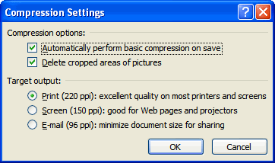

* Choose the target output.
* Change any of the default picture settings you wish.
* Click **OK** in the Compression Settings dialog box.
* Click **OK** in the Compress Pictures dialog box.

You need to monitor the **file size** of your images and documents that include images, especially if you send them via email. Cropping and resizing an image doesn’t decrease the image file size, but compression does.

##### Other Picture Tools

There are many other things you can do to modify a picture. From the Format tab, some of the other useful commands include:

* **Change Picture command**: Select a new picture from your computer.
* **Reset Picture command**: Revert to original image.
* **Brightness command**: Adjust the brightness of the image.
* **Color command**: Adjust the contrast of the image from light to dark.
* **Recolor command**: Modify the color in a variety of ways including Black and white, sepia, pink, purple, and more.

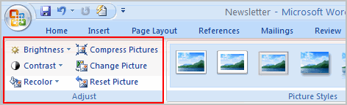

##### To Change the Shape of a Picture:

* Select the picture.
* Select the **Format** tab.
* Click the **Picture Shape** icon. A menu appears.

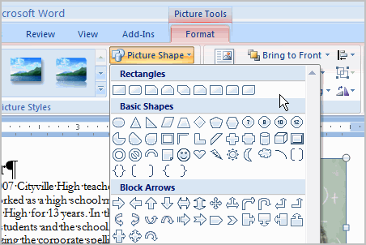

* Left-click a shape to select it.

##### To Apply a Picture Style:

* Select the picture.
* Select the **Format** tab.
* Click the **More** drop-down arrow to display all the picture styles.
* Hover over a picture style to display a Live Preview of the style in the document.

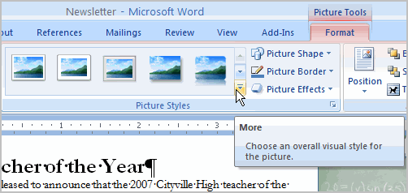

* Left-click a style to select it.

##### To Add a Border to a Picture Manually:

* Select the picture.
* Select the **Format** tab.
* Left-click the **Picture Border** command and select a color.

OR

* Select **Weight** from the menu and choose a line weight.

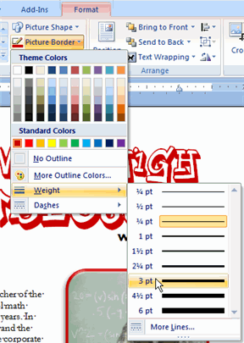

**Challenge!**

**Use the Newsletter or any Word document you choose to complete this challenge.**

* Insert a picture into a document.
* Crop the image proportionally.
* Apply a **picture style** to the image.
* Compress the picture.

### Columns and Ordering

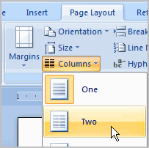Two useful formatting features in Word are the **columns** and **ordering** commands. **Columns** are used in many types of documents, but are most commonly used in newspapers, magazines, academic journals, and newsletters. **Ordering** is the process of layering two or more shapes so that they appear in a certain way. For example, if you have two shapes that overlap and want one shape to appear on top, you will have to **order** the shapes.  
  
In this lesson you will learn how to insert columns into a document and order an image and a shape.

### Inserting Columns and Ordering Objects

[Watch the video!](http://www.gcflearnfree.org/content/screencasts/shared/player_776x600.aspx?screenCast=wd07_columns) (3:32 min) - [Tips](http://www.gcflearnfree.org/PopUps/VideoTips.aspx) for watching our videos.

Download the [example](http://www.gcflearnfree.org/content/downloads/wd07_Newsletter_lesson17.docx) to work along with the video.

##### To Add Columns to a Document:

* Select the text you want to format.
* Select the **Page Layout** tab.
* Left-click the **Columns** command.

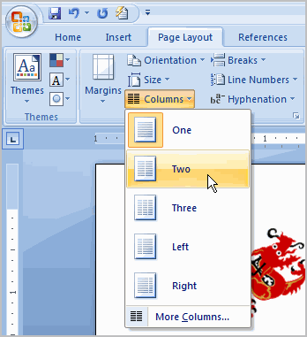

* Select the number of columns you would like to insert.

Click the **Show/Hide** command on the Home tab to display the **paragraph marks** and **breaks**.

The **Format Painter** command allows you to easily format text to appear like other text in your document. Select the text that is formatted the way you want, click the **Format Painter** command on the Home tab, and then select the text you want to change. The new text now appears modified.

##### To Change the Order of Objects:

* Right-click the object you wish to move. In this example, click the shape.
* In the menu that appears, select **Order**.

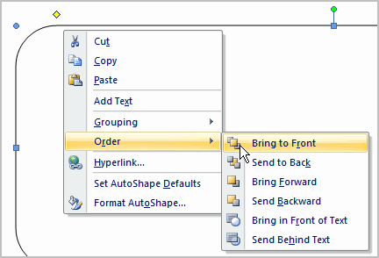

* Select a menu option that will arrange the item in the desired way. In this example, select Send Behind Text.
* The text and image are now displayed layered on top of the shape.

**Use the Newsletter or any Word document you choose to complete this challenge.**

* Select **text** you want to format into columns.
* Format the selected text into **two columns**.
* Insert a picture and a shape.
* Practice ordering using the picture and shape.

### Working with Headers and Footers

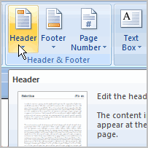You can make your document look **professional and polished** by utilizing the header and footer sections. The **header** is a section of the document that appears in the **top margin**, while the **footer** is a section of the document that appears in the **bottom margin**. Headers and footers generally contain information such as page number, date, document name, etc.   
  
In this lesson, you will learn how to insert built-in and blank headers and footers.

### Headers and Footers

[Watch the video!](http://www.gcflearnfree.org/content/screencasts/shared/player_776x600.aspx?screenCast=wd07_header_footer) (3:24 min) - [Tips](http://www.gcflearnfree.org/PopUps/VideoTips.aspx) for watching our videos.

Download the [example](http://www.gcflearnfree.org/content/downloads/wd07_Newsletter_lesson18.docx) to work along with the video.

##### To Insert a Header or Footer:

* Select the **Insert** tab.
* Click either the **Header** or **Footer** command. A menu appears with a list of **built-in options** you can use.
* Left-click one of the built-in options and it will appear in the document.

OR

* Left-click **Blank** to select it.

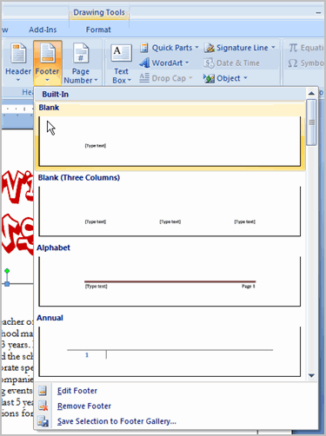

The **Design** tab with **Header** and **Footer** tools is active.

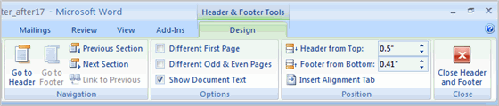

* Type information into the header or footer.

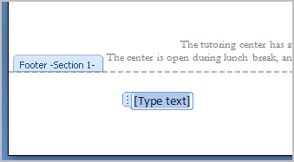

##### To Insert the Date or Time into a Header or Footer:

* With the header or footer section active, click the **Date & Time** command.

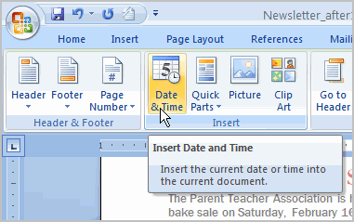

* Select a **date format** in the dialog box that appears.

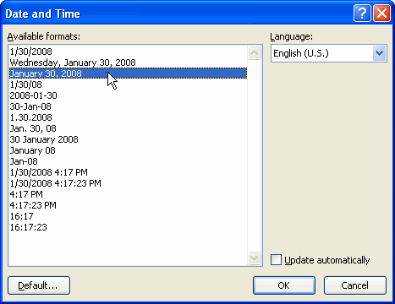

* Click OK. The date/time now appears in the document.

##### Other Header and Footer Options

There are many other **header and footer options** that you can use to design these sections of your document. From the Header and Footer Tools Design tab, you can see all your design options.

**Use the Newsletter or any Word document you choose to complete this challenge.**

* Add your name in the **header** of a document.
* Right-align the text in the header.
* Select a **built-in footer** with page number.

### Working with Tables

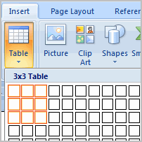A **table** is a grid of cells arranged in **rows** and **columns**. Tables can be customized and are useful for various tasks such as presenting text information and numerical data.   
  
In this lesson, you will learn how to convert text to a table, apply table styles, format tables, and create blank tables.

### Inserting and Modifying Tables

[Watch the video!](http://www.gcflearnfree.org/content/screencasts/shared/player_776x600.aspx?screenCast=wd07_tables) (5:14 min) - [Tips](http://www.gcflearnfree.org/PopUps/VideoTips.aspx) for watching our videos.

Download the [example](http://www.gcflearnfree.org/content/downloads/wd07_Report_lesson19.docx) to work along with the video.

##### To Convert Existing Text to a Table:

* Select the text you wish to convert.
* Select the **Insert** tab.
* Click the **Table** command.
* Select **Convert Text to Table** from the menu.A dialog box appears.

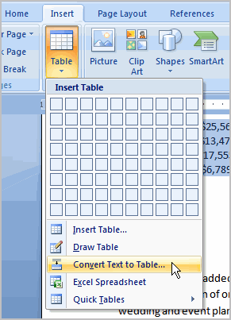

* Choose one of the options in the **Separate text at:** section. This is how Word knows what text to put in each column.

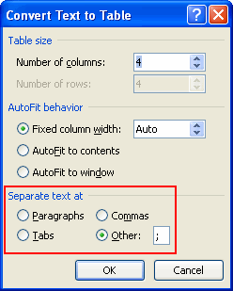

* Click OK. The text appears in a table.

##### To Add a Row Above an Existing Row:

* Place the insertion point in a row below the location you wish to add a row.

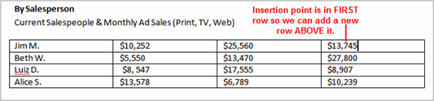

* Right-click the mouse. A menu appears.
* Select Insert actionInsert Rows Above.

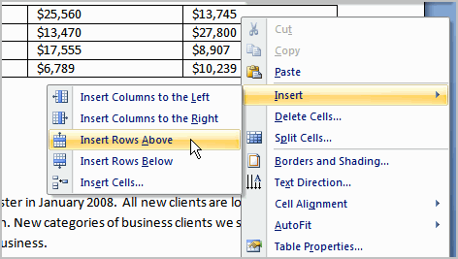

A new row appears **above** the insertion point.

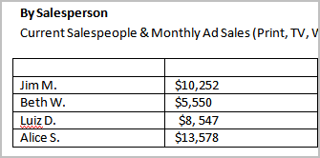

You can also add rows below the insertion point. Follow the same steps, but select Insert Rows Below from the menu.

##### To Add a Column:

* Place the **insertion point** in a **column** **adjacent** to the location you wish the new column to appear.
* Right-click the mouse. A menu appears.
* Select **Insert** action**Insert Columns to the Left** or **Insert Columns to the Right**. A new column appears.

##### To Delete a Row or Column:

* Select the row or column.
* Right-click your mouse and a menu appears.
* Select **Delete Columns** or **Delete Rows**.

##### To Apply a Table Style:

* Select the table. A **Table Tools Design** tab now appears on the Ribbon.
* Select the **Design** tab to access all the **Table Styles** and **Options**.

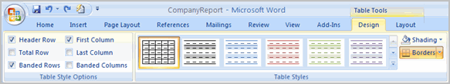

* Click through the various styles in the **Table Styles** section.
* Left-click a style to select it. The table style will appear in the document.

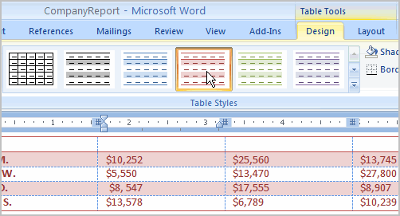

You can modify which table styles are displayed. In the **Table Styles Options** you can select and deselect various table options. For example, you can select Banded Rows and only tables with banded rows will appear in the Tables Styles section.

Want to have a little more creative freedom when it comes to formatting your tables? You can manually change the table border or shading, change line weight, or erase part of the table.

##### To Insert a Blank Table:

* Place your insertion point in the document where you want the table to appear.
* Select the **Insert** tab.
* Click the **Table** command.
* Drag your mouse over the diagram squares to select the number of columns and rows in the table.

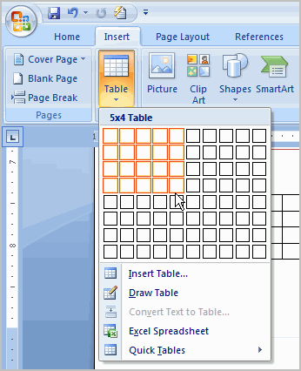

* Left-click your mouse and the table appears in the document.
* Enter text into the table.

##### Modify a Table Using the Layout Tab

When you select a table in Word 2007, **Design** and **Layout** tabs appear under **Table Tools** on the Ribbon. Using commands on the Layout tab you can make a variety of modifications to the table such as:

* Adding and deleting columns,
* Adding and deleting rows,
* Changing the cell size,
* Aligning cell text,
* Changing text direction,
* Merging and splitting cells,
* And More.

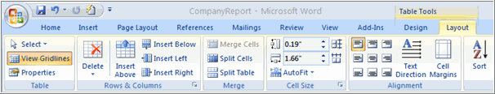

**Use the Report or any Word document you choose to complete this challenge.**

* Convert text into a table.
* Apply a table style.
* Delete a row from the table.
* Insert a blank table with five rows and four columns.

### Using SmartArt Graphics

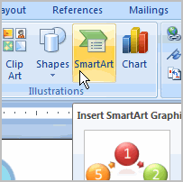SmartArt allows you to **visually communicate information** rather simply using text. Illustrations can really make an impact in your document and SmartArt makes using graphics especially easy.  
  
In this lesson, you will learn how to insert a SmartArt graphic, change the color and effects of the illustration, and modify it in numerous ways.

### SmartArt Graphics

[Watch the video!](http://www.gcflearnfree.org/content/screencasts/shared/player_776x600.aspx?screenCast=wd07_smart_art) (8:11 min) - [Tips](http://www.gcflearnfree.org/PopUps/VideoTips.aspx) for watching our videos.

Download the [example](http://www.gcflearnfree.org/content/downloads/wd07_Report_lesson20.docx) to work along with the video.

##### To Insert a SmartArt Illustration:

* Place the insertion point in the document where you want the graphic to appear.
* Select the **Insert** tab.
* Select the **SmartArt** command in the Illustrations group. A dialog box appears.

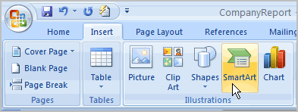

* Select a **category** on the left of the dialog box and review the SmartArt graphics that appear in the **center**.
* Left-click a graphic to select it.

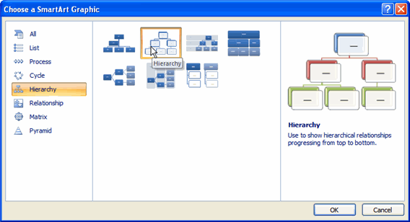

* Click OK.

To see more details about a graphic, left-click any image, and a larger version of the graphic and **additional text details** will appear on the **right side** of the dialog box.

##### To Add Text to a SmartArt Graphic:

* Select the graphic. The **first text box** is selected. If the task pane on the left of the graphic is visible, the **insertion point** appears in it. If the task pane is not visible, click the arrow to open the task pane.
* Enter text into the task pane fields. The information will appear in the graphic.

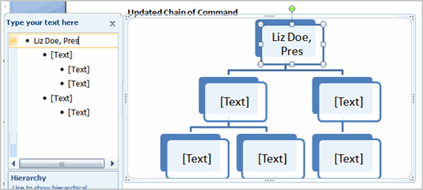

OR

* Click **X** to close the task pane.
* Enter text into the **first text box** in the graphic.
* Continue to enter text in the text box graphics.

Notice the text you enter **automatically** resizes to fit inside the box.

##### To Add a Shape to a Graphic:

* Select the graphic. The **SmartArt Tools Design and Format tabs** appear on the Ribbon.
* Select the **Design** tab.
* Click the **Add Shape** command in the Graphics group.
* Decide where you want the **new shape** to appear and select one of the shapes nearby the desired location.
* Select **Add Shape Before** or **Add Shape After**. If we wanted to add a superior or a subordinate, we could select the **Above** or **Below** options.

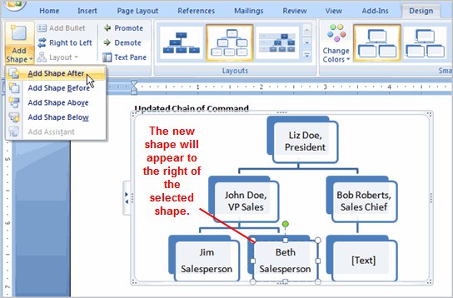

##### To Move Shapes Using the Promote or Demote Commands:

* Select the graphic. The SmartArt Tools Design and Format tabs appear on the Ribbon.
* Select the **Design** tab.
* Select the **shape** you would like to move.
* Click the **Promote** or **Demote** commands in the Create Graphic group.

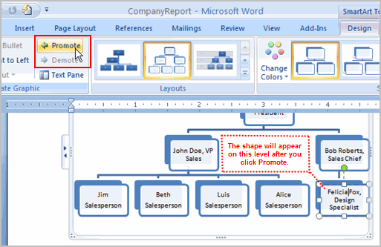

The **Promote** and **Demote** commands allow you to move shapes and really customize the graphic, rather than having to use the predefined default illustration.

##### To Change the Graphic Style:

* Select the graphic. The SmartArt Tools Design and Format tabs appear on the Ribbon.
* Select the Design tab.
* **Left-click a style** to select it.

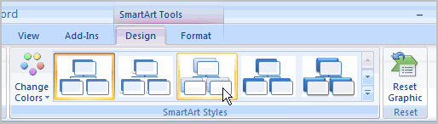

Click the **More** arrow to see all the style options. Hover over each to display a Live Preview of the style in your document.

##### **To Change the Color Scheme:**

* Select the graphic. The SmartArt Tools Design and Format tabs appear on the Ribbon.
* Select the Design tab.
* Click the **Change Color** command. A menu of color schemes appear.
* Left-click an option to select it.

Explore the options in the **Layout** group if you would like to switch to another graphic, but keep the existing text. Also, you can select the **Format** tab to access additional formatting options including fill, text, and line color.

Some of the options will differ from graphic to graphic. Look carefully at the SmartArt Tools tabs and explore the active commands.

**Challenge!**

**Use the Report or any Word document you choose to complete this challenge.**

* Insert a SmartArt illustration into a document.
* Enter text into the graphic.
* Modify the style.
* Modify the graphic, as needed.

### Using Indents and Tabs

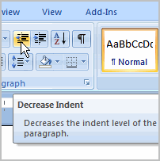A great way to **draw attention** to specific text is to **indent** it. There are several ways in Word that you can indent text; however, it’s important to use these tools appropriately and **indent correctly** each time. This can save time and make the editing process go smoothly.  
  
In this lesson, you will learn how to use the **tab selector** and the **horizontal ruler** to set tabs and indents, and how to use the Increase and Decrease **Indent commands**.

### Indents and Tabs

[Watch the video!](http://www.gcflearnfree.org/content/screencasts/shared/player_776x600.aspx?screenCast=wd07_tabs_indents) (8:44 min) - [Tips](http://www.gcflearnfree.org/PopUps/VideoTips.aspx) for watching our videos.

Download the [example](http://www.gcflearnfree.org/content/downloads/wd07_Report_lesson21.docx) to work along with the video.

Click the **Show/Hide** command on the Home tab. This will allow you to see the nonprinting characters such as the spacebar, paragraph, and Tab key markings.

##### To Indent Using the Tab Key:

The most common way to indent is to use the **Tab** key. This method is best for indenting one line of text, rather than multiple lines.

* Place the insertion point to the **left** of text you wish to indent.
* Press the **Tab** key. This indents the line 1/2 inch by default.

##### To Use the Indent Commands:

Using the Tab key to **indent multiple lines** can make formatting difficult if you add or remove text later. Indenting multiple lines is best done using the **Indent commands**.

* Select the text you wish to indent.
* Click the **Increase Indent** command to **increase** the indent. The default is 1/2 an inch. You can press the command multiple times.

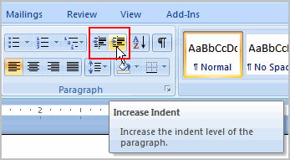

* Click the **Decrease Indent** command to **decrease** the indent.

##### To Modify the Default Indent Settings:

* Select the **Page Layout** tab.
* Select the text you would like to modify.
* Use the **arrows** or enter text in the fields to modify the **Left** and **Right Indents**.

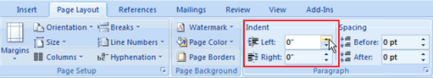

##### The Tab Selector

The **tab selector** is above the **vertical ruler** on the left. Hover over the tab selector to see the name of the type of tab that is active.

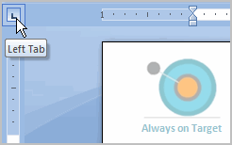

**The tab options are:**

* **First Line Indent** Right Tab Icon: Inserts the indent marker on the ruler and indents the first line of text in a paragraph.
* **Hanging Indent** Right Tab Icon: Inserts the hanging indent marker and indents all lines other than the first line.
* **Left Tab** LeftTab Icon: Moves text to the right as you type.
* **Center Tab** Right Tab Icon: Centers text according to the tab.
* **Right Tab** Right Tab Icon: Moves text to the left as you type.
* **Decimal Tab** Right Tab Icon: Aligns decimal numbers using the decimal point.
* **Bar Tab** Right Tab Icon: Draws a vertical line on the document.

##### To Set a Tab Stop to Indent the First Line of Text:

* Click the **tab selector** until the **First Line Indent** icon is visible.
* Left-click at any point on the **horizontal ruler**. The First Line Indent icon will appear.

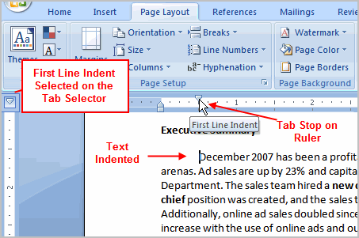

* Press the **Enter** key to start a new paragraph and your insertion point will automatically indent to that point. I

To move a tab stop once you have inserted it, left-click and drag the tab stop back and forth on the ruler.

You can set the **Hanging Indent** the the same way; however this tab stop changes all the **other lines** in a paragraph.

##### To Set the Left, Center, Right, and Decimal Tab Stops:

* Click the **tab selector** until the tab stop you wish to use appears.
* Left-click the **location on the horizontal ruler** where you want your text to appear.

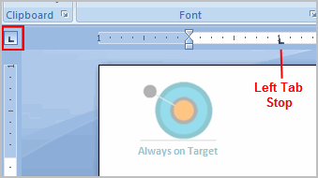

* Press the **Tab** key to reach the tab stop.

##### To Use Find and Replace to Replace Existing Text:

* Click the **Replace** command on the Home tab. The Find and Replace dialog box appears.

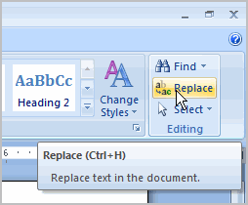

* Enter text in the **Find** field that you wish to locate in your document.
* Enter text in the **Replace** field that will replace the text in the Find box.

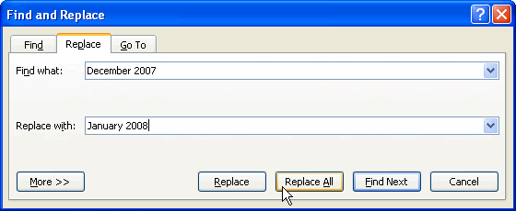

* Click OK. The change is made in the document.

You can also use the **Find command** to locate **specific information** in a document. For example, if you are working with a twenty page report, it would be time consuming to search the document for a specific topic. You can use the Find command to locate **all instances** of the word or phrase in the document. This is a great way to **save time** when working with long documents.

**Challenge!**

**Use the Report or any Word document you choose to complete this challenge.**

* Practice using the **Tab** key to indent the first line of a paragraph.
* Select some text and use the **Increase** and **Decrease** Indent commands to see how they change the text.
* Explore the tab selector and all the tab stops. Practice using each one.

### Applying Styles and Themes

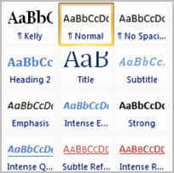Styles and themes are powerful tools in Word that can help you create professional looking documents easily. A **style** is a predefined combination of font style, color, and size of text that can be **applied to selected text**. A **theme** is a set of formatting choices that can be applied to an **entire document** and includes theme colors, fonts, and effects.   
  
In this lesson you will learn how to apply, modify and create a style, use style sets, apply a document theme, and create a custom theme.

### Styles and Themes

[Watch the video!](http://www.gcflearnfree.org/content/screencasts/shared/player_776x600.aspx?screenCast=wd07_styles_themes) (10:31 min) - [Tips](http://www.gcflearnfree.org/PopUps/VideoTips.aspx) for watching our videos.

Download the [example](http://www.gcflearnfree.org/content/downloads/wd07_Report_lesson22.docx) to work along with the video.

##### To Select a Style:

* Select the **text** to format. In this example, the title is selected.
* In the **Style group** on the Home tab, hover over each style to see a live preview in the document. Click the **More** drop-down arrow to see additional styles.

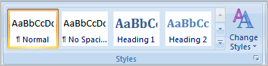

* Left-click a style to select it. Now the **selected text appears formatted** in the style.

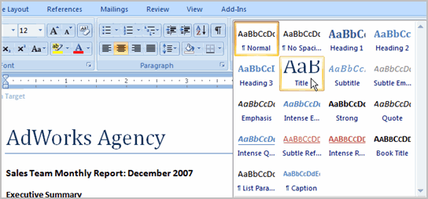

##### To Modify a Style:

* Select the **text in the style** you want to change. In this example, we are changing AdWorks Agency, which has the Title style applied.
* Locate the style in the **Styles group**.
* Right-click the style and a menu appears.
* Left-click **Modify** and the Modify Style dialog box appears.

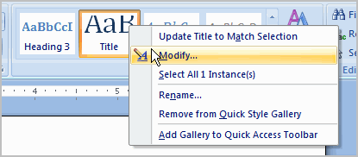

* Change any of the formatting.

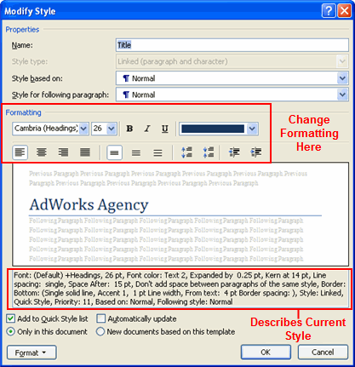

* Click **OK** to apply the modifications to the style.

##### To Create a New Style:

* Click the **arrow** in the bottom right corner of the Styles group. This opens the Styles task pane.

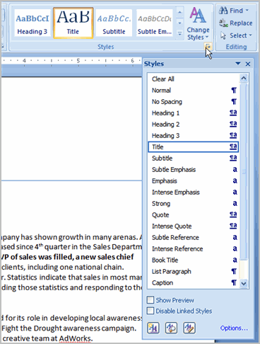

* Click the **New Style** button at the bottom and a dialog box appears.

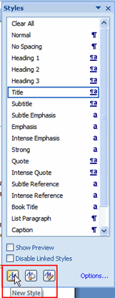

* Enter a name for the style and make all the formatting decisions.

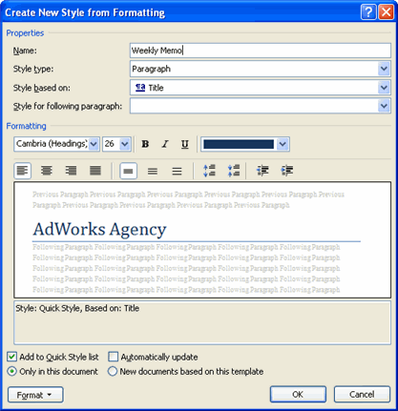

* Select the **button** beside **New Document based on this template**, so the style will be available to use in all your documents.
* Click **OK**. The new style will appear in the list.

##### To Apply a Style Set:

* Click the **Change Styles** command on the Ribbon.
* Select **Style Set** from the menu that appears.

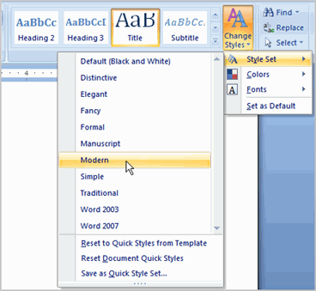

* Left-click a style set to select it. The change is reflected in the entire document.

**Style sets** include a combination of title, heading, and paragraph styles. Style sets allow you to **format all the elements of your document** at once, rather than formatting your title and headings separately.

For quick changes, you can modify the colors and fonts of a style set from the Change Styles command; however, the **themes** feature is more comprehensive and easy-to-use.

##### To Apply a Theme:

* Select the **Page Layout** tab.
* Click the **Themes** command.

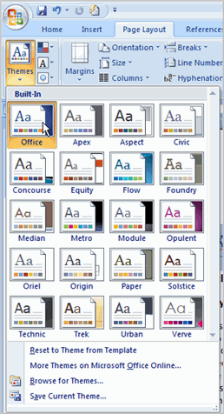

* Hover your pointer over a theme to see it displayed in the document.
* **Left-click** a theme to select it.

A **document theme** is a set of formatting choices that include font styles, sizes, and colors for different parts of the document and a set of theme effects such as lines and fill effects.

##### To Create a Custom Theme:

* Open the document you'd like to format.
* Select the **Page Layout** tab.
* Click the **Colors** command.
* Select **Create New Theme Colors**. A dialog box appears.

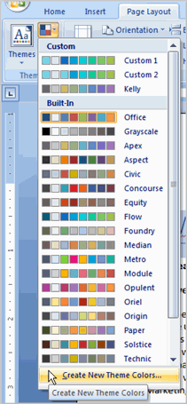

* Use the **drop-down menus** to change the colors for each part of the document.

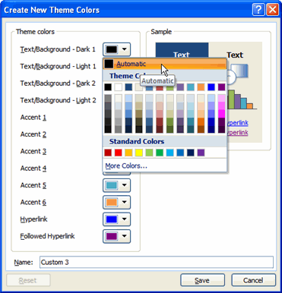

* Enter a **name for the** theme color.
* Click **Save**.
* Click the **Fonts** command.
* Select **Create New Theme Fonts**. A dialog box appears.

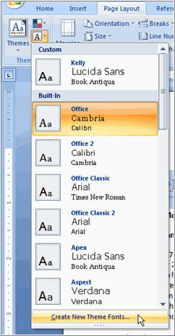

* Use the drop-down menus to **change the fonts** in the dialog box.
* Enter a name for theme font.

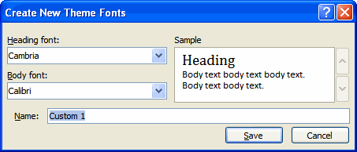

* Click **Save**.
* Click the **Effects** command and select an option from the drop-down menu.
* Click the **Themes** command.
* Select **Save Current Theme**. A dialog box appears.

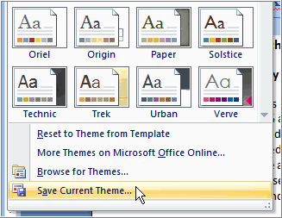

* Enter a **theme name** and click **Save**. Now the theme is available to use with other documents.

You can not apply a Theme to a document without **applying styles first**. Themes look for and replace the formats of each of the styles.

**Challenge!**

**Use the Report or any Word document you choose to complete this challenge.**

* Apply a style to one section of your document.
* Apply a **style set** to your entire document.
* Modify an existing style.
* Apply a **theme**.

### Using Mail Merge

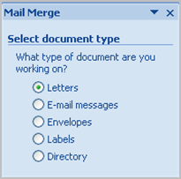Mail merge is a useful tool that will allow you to easily produce multiple letters, labels, envelopes and more using information stored in a list, database, or spreadsheet. In this lesson, you will learn how to use the **mail merge wizard** to create a **data source** and a form **letter**, and explore other wizard features. Additionally, you will learn how to use the Ribbon commands to access the mail merge tools outside of the wizard.

### Mail Merge

[Watch the video!](http://www.gcflearnfree.org/content/screencasts/shared/player_776x600.aspx?screenCast=wd07_mail_merge) (11:01 min) - [Tips](http://www.gcflearnfree.org/PopUps/VideoTips.aspx) for watching our videos.

Download the [example](http://www.gcflearnfree.org/content/downloads/wd07_Letter_lesson23.docx) to work along with the video.

##### To Use Mail Merge:

* Select the **Mailings** on the Ribbon.
* Select the **Start Mail Merge** command.

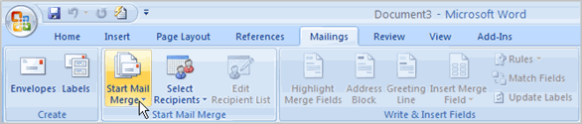

* Select **Step by Step Mail Merge Wizard**.

The Mail Merge task pane appears and will guide you through the **six main steps** to complete a mail merge. You will have many decisions to make during the process. The following is an example of how to create a form letter and merge the letter with a data list.

##### **Steps 1-3**

* Choose the type of document you wish to create. In this example, select **Letters**.
* Click **Next:Starting document** to move to Step 2.
* Select **Use the current document**.
* Click **Next:Select recipients** to move to Step 3.
* Select the **Type a new list** button.
* Click **Create** to create a data source. The **New Address List** dialog box appears.

**To Customize the New Address List:**

* + Click **Customize** in the dialog box. The Customize Address List dialog box appears.

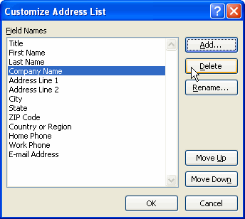

* + Select any field you do not need and click **Delete**.
  + Click **Yes** to confirm that you wish to delete the field.
  + Continue to delete any unnecessary fields.
  + Click **Add**. The Add Field dialog box appears.
  + Enter the new field name.
  + Click OK.
  + Continue to add any fields necessary.
  + Click **OK** to close the Customize Address List dialog box.
* Enter the necessary data in the New Address List dialog box.
* Click **New Entry** to enter another record.
* Click **Close** when you have entered all your data records.
* Enter the file name you wish to save the data list as.
* Choose the location you wish to save the file.
* Click **Save**. The Mail Merge Recipients dialog box appears and displays all the data records in the list.
* Confirm the data list is correct and click **OK**.
* Click **Next:Write your letter** to move to Step 4.

##### Steps 4-6

* Write a letter in the current Word document, or use an open, existing document.

##### To Insert Recipient Data from the List:

* + Place the insertion point in the document where you wish the information to appear.
  + Select Address block, Greeting line, or Electronic postage from the task pane. A dialog box with options will appear based on your selection.

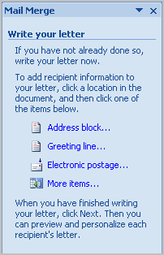

OR

* + Select More Items. The Insert Merge Field dialog box will appear.
  + Select the field you would like to insert in the document.
  + Click **Insert**. Notice that a placeholder appears where information from the data record will eventually appear.
  + Repeat these steps each time you need to enter information from your data record.
* Click **Next: Preview your letters** in the task pane once you have completed your letter.
* Preview the letters to make sure the information from the data record appears correctly in the letter.
* Click **Next: Complete the merge**.
* Click **Print** to print the letters.
* Click **All**.
* Click **OK** in the Merge to Printer dialog box.
* Click **OK** to send the letters to the printer.

The Mail Merge wizard allows you to complete the mail merge process in a variety of ways. The **best** way to learn how to use the different functions in Mail Merge is to try to develop several of the different documents -- letters, labels, envelopes -- using the different types of data sources.

**Challenge!**

**Use the Report or any Word document you choose to complete this challenge.**

* Open a new, blank Word document.
* Open the **Mail Merge** task pane.
* Create a **data list** and practice adding and removing fields.
* Explore the different Mail Merge features until you are familiar with them.

**Peripherals You Can Use in Various Ports**

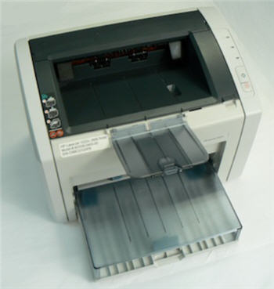Printer

* **Printers**: A **printer** is a **peripheral** that is used to print, or produce, a version of what appears on the screen in a **hardcopy** format. There are many types of printers available including ink-jet, laser-jet, and photo printers. Also, combination printers that include scanners and copiers are increasing in popularity.
* **Scanners**: A **scanner** allows you to **copy an image or document** and save it in electronic form onto your computer. While you can purchase a hand-held and flatbed scanners, you are more likely to purchase a scanner as an all-in-one option that combines a scanner, printer, and copier into one product.   
    
  Scanners vary in **resolution**, or sharpness, so when shopping for one, be sure to compare the resolution of the products. A scanner is connected to the computer via a parallel port, a USB port, or a SCSI connection. No matter which connection is used, the images are stored on your PC's hard drive in a digital format.

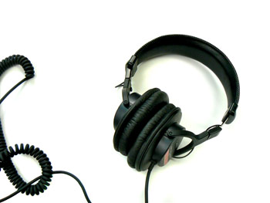Headphones

* **Speakers/Headphones**: **Speakers** and **headphones** are output devices, which means that they are devices that communicate information from the computer to the user. They allow you to **hear sound and music**. Both speakers and headphones connect to a computer; however, some computers are designed with speakers built into the monitor.
* **Microphones**: A **microphone** is a type of input device, or a device that receives information from a user. You connect the microphone to the computer and use the computer to record sound or to communicate with another computer user via the Internet. Many computers come with built-in microphones.

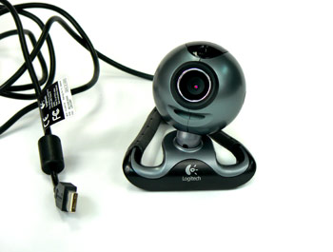Web Camera

* **Web Cameras**: **Web cameras**, or web cams, are devices that connect to a computer and **display a video image** of whatever it is recording. This video image can be transmitted over the Internet, allowing a user in another location the ability to see the video in real-time. Web cameras are used often in business for video conferences, and are also a great tool for families to use to stay connected from different parts of the world.
* **Joystick or Game Controller**: A **joystick** is a lever used while playing a computer game.
* **Digital Cameras**: A **digital camera** lets you capture a picture in **digital (computer-readable) form**. You can transfer that image directly from the camera to the computer. When you use a digital camera, you can also preview your pictures before printing them. If you don't like what you see, you can edit or delete them.

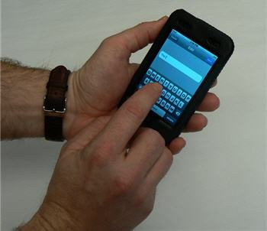Personal Digital Assistant

* **Personal Digital Assistant (PDA)**: A PDA is a **handheld computer** that can have a variety of features including a calendar, Internet access, video recording, word processing, email access, phone, media player, and more. Most PDAs can be synchronized with a PC to allow up-to-date contact information stored on software such as Microsoft Outlook, RSS feeds, or other web updates.
* **MP3 Players**: An **MP3 player** is a **portable device** that stores, organizes, and **plays** audio files. The player can read files that are recorded from a CD using a computer, or downloaded from various sites via the Internet.